**Hypothesis** – Linear regression line

$$h\left(θ\right)= θ_{0}+ θ_{1}x$$

**Cost Function** – We minimise $θ_{0} and θ_{1}$ and update them constantly to reach best values in order to improve efficiency of our model and reduce error between predicted and true label.

Cost function of linear regression model is Root mean square error (RMSE) between predicted and true value

$$J\left(θ\right)= \frac{1}{2m}\sum_{i=1}^{m}{{(h_{θ}\left(x^{\left(i\right)}\right)- y^{\left(i\right)})}^{2}}$$

Where

$h_{θ}\left(x^{\left(i\right)}\right)=Predicted Value$

$$y^{\left(i\right)}=Actual Value$$

$$m=Training samples$$

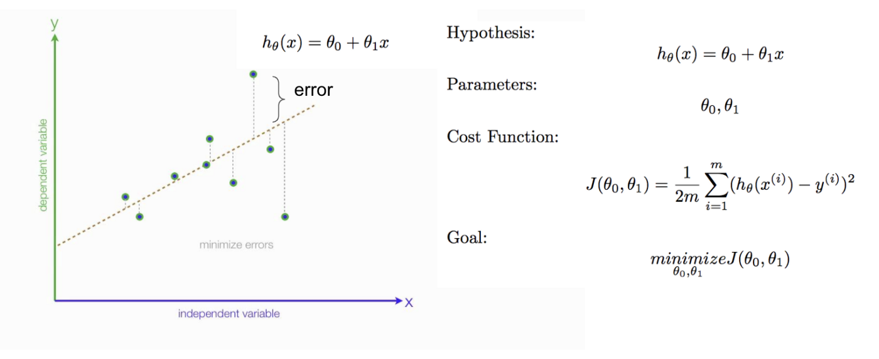

**Gradient Descent –**

Continuous minimisation of cost function which ultimately leads to reduction in values of $θ_{0} and θ_{1}$ thus in the end generating minimum parameters fitting best to the given dataset.

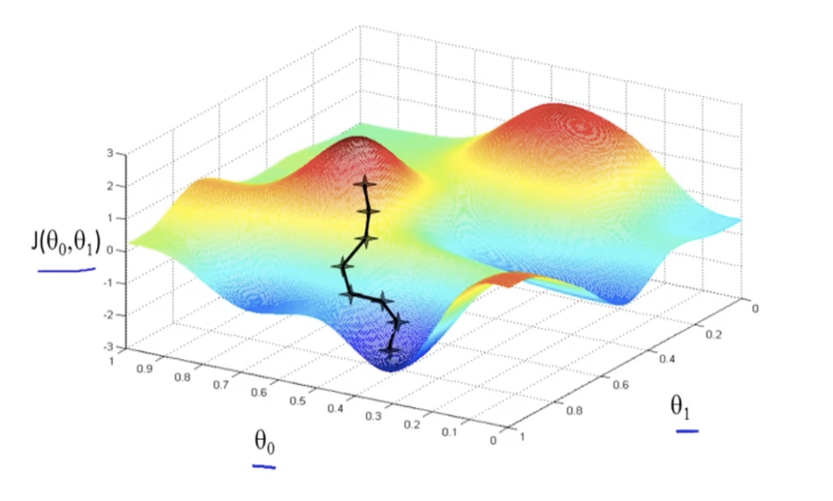

Algorithm –

$$repeat till convergence=\{$$

$$θ_{j }≔ θ_{j}- α\frac{∂}{∂θ_{j}}J(θ_{0},θ_{1})$$

$$\}$$

Simultaneous Update –

$$repeat till convergence=\{$$

$${temp}_{0 }≔ θ_{0}- α\frac{∂}{∂θ_{0}}J(θ_{0},θ_{1})$$

$${temp}_{1 }≔ θ_{1}- α\frac{∂}{∂θ_{1}}J(θ_{0},θ_{1})$$

$$θ_{0}≔{temp}_{0 }$$

$$θ_{1}≔{temp}_{1 }$$

$$\}$$

$α$ is called as **learning rate**. It controls how big steps we take from one point to another/ it decides the next point which algorithm will go to.

